Project Documentation
Script-Controlled ACL – Restrict Record Access Based on Field Value
Team Members
Name | Role
Dinesh Rajan | Team Leader
Divya A | Team Member
Dharshini V | Team Member
Dharshan Rajaram | Team Member
Part A – Project Report Part B – Project Documentation
Part A
Project Report

1. INTRODUCTION

1.1 Project Overview
This project builds script-controlled Access Control Lists (ACLs) in ServiceNow so that access to a record depends on the value of one of its fields (for example, Confidential) and on the user’s role. Standard role-based ACLs give every role holder access to all records in a table. Here, a short server-side script checks the record’s field value with current.<field> and the user’s role, then sets answer = true or false.
The ACLs are created for the READ, CREATE, WRITE and DELETE operations on a custom table. The work was split into seven milestones: users and roles, table, the four ACLs, and the conclusion. The ACLs are tested by impersonating users with different roles and by reviewing the system logs.

1.2 Purpose
The purpose of the project is to make sure that only authorized users can see or change records that carry a restricted field value, without blocking legitimate users from the records they need. The goals are:
- Give precise, record-level security that is easy to maintain.
- Reduce the risk of data leaks and give confidence in audits and compliance.
- Let authorized users, including record owners, keep working on their own records.
- Provide one reusable script pattern that can be applied to other tables and fields.

2. IDEATION PHASE

2.1 Problem Statement
PS | I am (Customer) | I’m trying to | But | Because | Which makes me feel
PS-1 | A ServiceNow administrator responsible for data security | Restrict access to records based on the value of a field (e.g., Confidential) | Role-based ACLs give every role holder access to all records in the table | Standard ACL conditions cannot evaluate record-specific field values without a script | Worried and exposed to data-leak risk
PS-2 | A ServiceNow developer who writes and maintains ACLs | Write a script-controlled ACL that allows or denies access correctly | The script is hard to test and may block legitimate users or miss restricted ones | ACL scripts depend on evaluation order, roles and live field values, with limited debugging visibility | Anxious and uncertain about the result
PS-3 | A service desk agent / end user | Open only the records I am authorized to see and work on | I sometimes get denied on my own records or see records I should not | The ACL script rules and exceptions are not defined or applied consistently | Confused and frustrated

2.2 Empathy Map Canvas
Empathy map for the ServiceNow Administrator / Developer:
What does he THINK AND FEEL?  • “Will restricted records leak to users who should not see them?”  • “Will my script accidentally block legitimate users?”  • Worried about audit findings and data-privacy compliance  • Wants precise, record-level security that is easy to maintain | What does he HEAR?  • Manager: “Sensitive records must only be visible to the right people.”  • Colleagues: “Role-based ACLs are simpler, just use those.”  • Auditors: “Show how access is restricted per record.”  • Users: “I can’t open my own ticket!”
What does he SAY AND DO?  • Writes ACL scripts that check a field value (e.g., Confidential) using current.<field>  • Sets answer = true / false based on user role and field value  • Tests with impersonation and different roles  • Reviews ACL evaluation order and system logs | What does he SEE?  • Role-only ACLs exposing every record in a table to all role holders  • Sensitive records visible in lists and reports  • Inconsistent results between users  • ACL script errors and hard-to-trace denials in logs
PAIN  • Role-based ACLs are too coarse for record-level rules  • Scripts are hard to test and debug  • Fear of over-blocking or leaking data  • Confusing ACL evaluation order | GAIN  • Only authorized users see records with restricted field values  • Compliance and audit confidence  • Least-privilege access with clear, reusable logic  • Fewer support tickets about access issues

2.3 Brainstorming
The team (Dinesh Rajan, Dharshini V, Divya A and Dharshan Rajaram) selected the problem “How might we restrict record access using a script-controlled ACL based on a field value?”, wrote ideas on sticky notes, grouped them, and prioritized them by importance and feasibility. The ideas fell into five groups: write the core script that blocks records by field value, add exceptions so legitimate users keep access, test every scenario before release, make the logic reusable, fast and documented, and monitor and communicate denials.
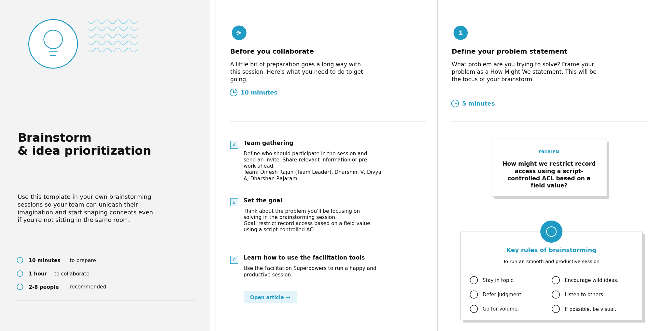
Step 1: Team gathering and problem statement
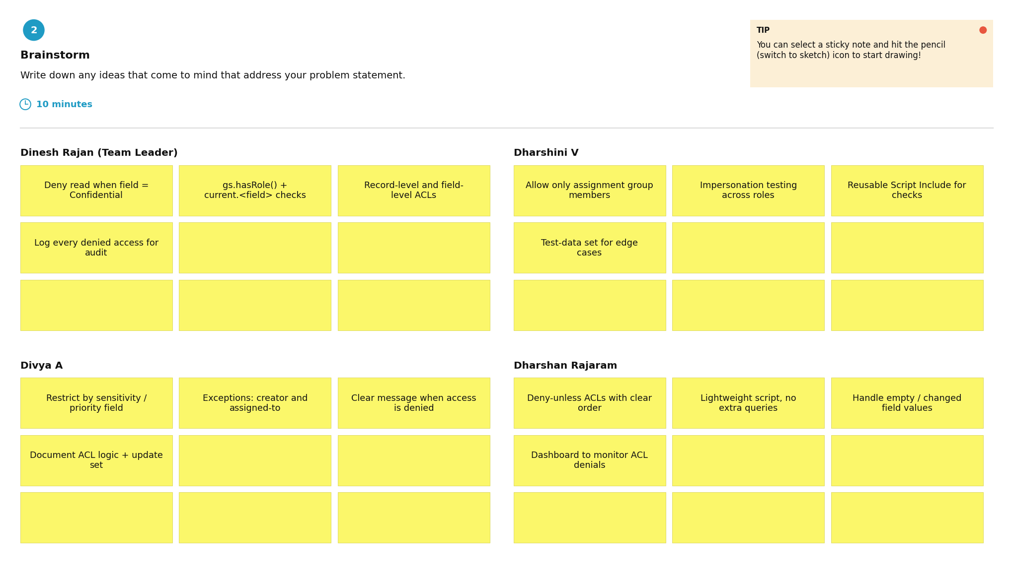
Step 2: Brainstorm and idea listing
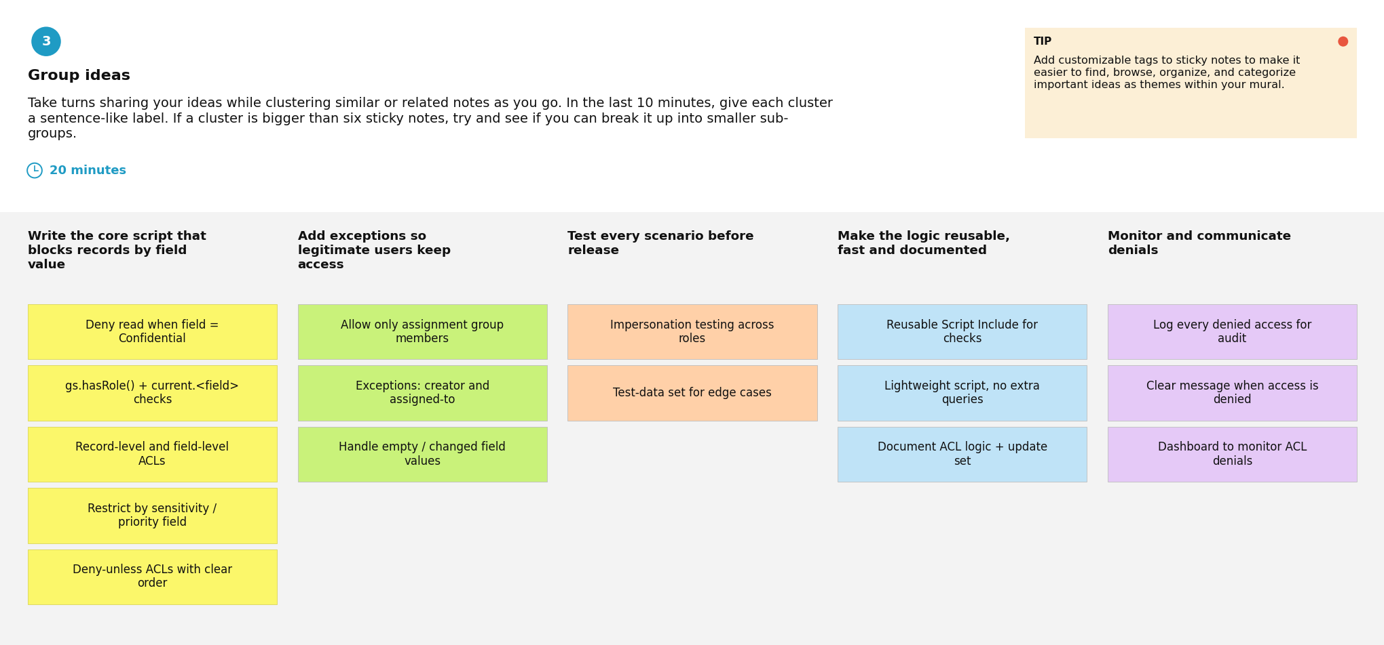
Step 3: Group ideas
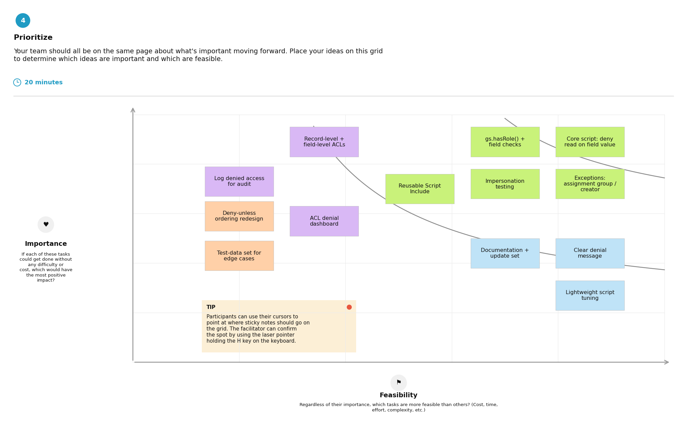
Step 4: Idea prioritization

3. REQUIREMENT ANALYSIS

3.1 Customer Journey map
Journey of the ServiceNow administrator / developer who configures, tests and uses a script-controlled ACL:
Stage | What happens | Goal | Pain point | Opportunity
Entice | An auditor or manager asks how access to sensitive records is restricted; the administrator finds that role-based ACLs expose every record | Find where sensitive records are exposed | Role-based ACLs expose every record in the table | List the tables whose records need field-based protection
Enter | Create the users, roles, table and restricted field (Milestones 1–2) and open a new ACL | Set up a clean test environment quickly | Unsure how the ACL evaluation order works | Reuse standard test users and roles; keep a one-page note on evaluation order
Engage | Write the ACL script with current.<field>, set answer = true / false, create READ, CREATE, WRITE and DELETE ACLs (Milestones 3–6) and test by impersonation | Allow or deny access correctly without blocking legitimate users | Scripts are hard to test and debug | Add log messages; keep a test matrix of role × field value × operation
Exit | Verify each role sees only the permitted records and review the logs | Confirm nothing leaks and show auditors how access is restricted | Inconsistent results; users still say “I can’t open my own ticket!” | Make sure record owners are never wrongly denied; write a short test report
Extend | Document the outcome (Milestone 7), reuse the logic for other tables and watch support tickets and logs | Keep the rules correct as roles and fields change | Scripts may break when roles or fields change | Use one reusable script pattern; review ACLs regularly

3.2 Solution Requirement
Functional Requirements
FR No. | Functional Requirement (Epic) | Sub Requirement (Story / Sub-Task)
FR-1 | User and Role Creation | Create users  Create roles  Assign roles to users
FR-2 | Table Creation | Create the table  Add the field that holds the restricted value (e.g., Confidential)
FR-3 | ACL – READ | Create a script-controlled READ ACL  Check the user’s role and current.<field>  Set answer = true or false
FR-4 | ACL – CREATE | Create a script-controlled CREATE ACL  Allow only authorized roles to create records
FR-5 | ACL – WRITE | Create a script-controlled WRITE ACL  Allow only authorized roles to edit restricted records
FR-6 | ACL – DELETE | Create a script-controlled DELETE ACL  Allow only authorized roles to delete restricted records
FR-7 | Testing and Verification | Impersonate users with different roles  Review ACL evaluation order and system logs  Confirm record owners are not wrongly denied
Non-functional Requirements
NFR No. | Non-Functional Requirement | Description
NFR-1 | Usability | ACL rules and scripts are clear and easy to read and maintain, and a denied user gets a consistent result.
NFR-2 | Security | Only authorized users can see or change records with a restricted field value; access follows least privilege and is enforced on the server by the ACLs.
NFR-3 | Reliability | The same user, role and field value always give the same result, and the script handles empty or unexpected field values without errors.
NFR-4 | Performance | The script only checks the user’s role and the current record’s field value, so lists and forms keep loading quickly.
NFR-5 | Availability | The ACLs run on the ServiceNow cloud instance, so access control is enforced whenever the instance is available.
NFR-6 | Scalability | The same script pattern can be reused for other tables, fields and roles without redesign.

3.3 Data Flow Diagram
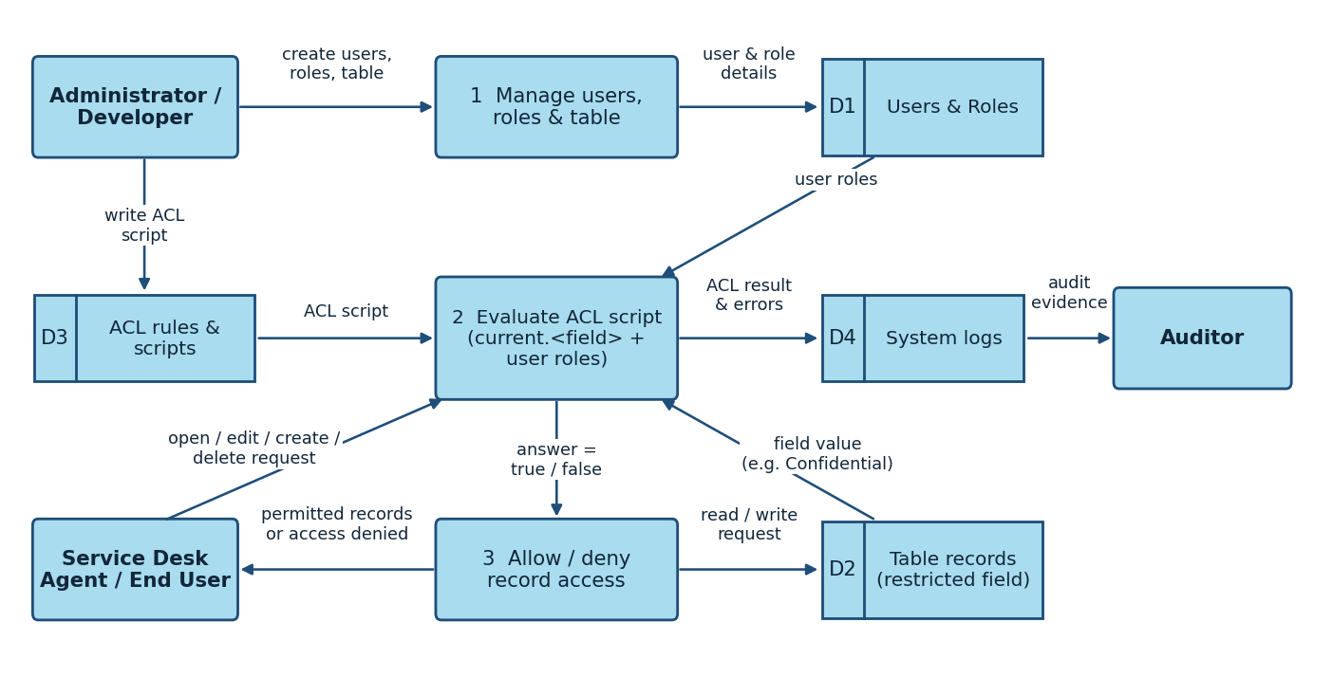
Figure: DFD Level 0 – Script-Controlled ACL
- The Administrator / Developer creates the users, roles and the table with the restricted field (Process 1, stored in D1).
- The Administrator / Developer writes the ACL script for READ, CREATE, WRITE and DELETE, which is stored as an ACL rule (D3).
- A service desk agent / end user requests to open, edit, create or delete a record.
- The ACL script is evaluated (Process 2): it checks the user’s roles (D1) and the record’s field value, current.<field> (D2).
- The script sets answer = true or false, and access is allowed or denied (Process 3).
- The ACL result and any script errors are written to the system logs (D4), which the Auditor can review.

3.4 Technology Stack
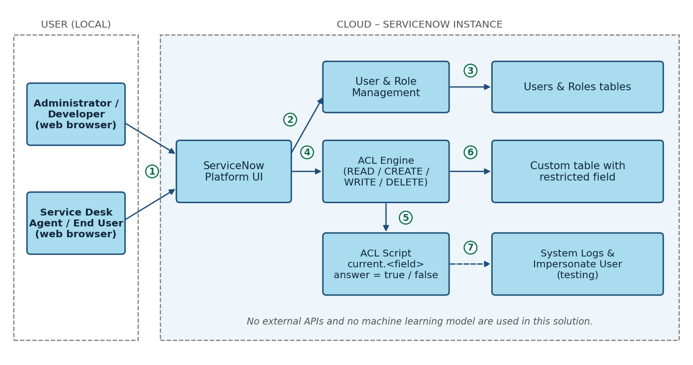
Figure: Technical architecture – Script-Controlled ACL on ServiceNow
Components & Technologies
S.No | Component | Description | Technology
1. | User Interface | Administrator, developer and end user work in a web browser | ServiceNow Platform UI
2. | Application Logic-1 | Creation of users and roles and assigning roles to users | ServiceNow user and role administration
3. | Application Logic-2 | ACL script checks current.<field> and the user’s role, then sets answer = true / false | ServiceNow server-side JavaScript
4. | Application Logic-3 | ACL rules for READ, CREATE, WRITE and DELETE and their evaluation order | ServiceNow Access Control (ACL) engine
5. | Database | Custom table with the restricted field, plus the users and roles tables | ServiceNow platform database
6. | Cloud Database | Records are stored in the ServiceNow instance | ServiceNow cloud instance
7. | File Storage | Not required | Not applicable
8.–9. | External API-1 / API-2 | No external API is used | Not applicable
10. | Machine Learning Model | No machine learning model is used | Not applicable
11. | Infrastructure (Server / Cloud) | Cloud deployment; no local server | ServiceNow-hosted instance
Application Characteristics
S.No | Characteristics | Description | Technology
1. | Open-Source Frameworks | No open-source framework is added | ServiceNow server-side JavaScript
2. | Security Implementations | Role-based access plus script-controlled ACLs, least privilege, testing with impersonation and log review | ACLs, roles, Impersonate User, System Logs
3. | Scalable Architecture | The same script pattern can be applied to other tables and fields | ServiceNow multi-tier cloud platform
4. | Availability | ACLs are enforced on the server of the cloud-hosted instance | ServiceNow cloud instance
5. | Performance | Short scripts that check only the user’s role and the current field value | ServiceNow ACL scripts

4. PROJECT DESIGN

4.1 Problem Solution Fit
Canvas box | Our answer
1. Customer Segment(s) – CS | ServiceNow administrators, developers and service desk agents / end users
2. Jobs-to-be-done / Problems – J&P | Restrict access to records by field value; write a script-controlled ACL that allows or denies correctly; let users open only the records they are authorized to see
3. Triggers – TR | Manager or auditors ask that sensitive records are visible only to the right people; sensitive records show up in lists and reports; a user reports “I can’t open my own ticket!”
4. Emotions: Before / After – EM | Before: worried, anxious, uncertain, confused and frustrated. After: confident in audits and compliance, in control with least-privilege access
5. Available Solutions – AS | Role-based ACLs (simple, but too coarse); standard ACL conditions (cannot check field values); manual testing by impersonation and log review (slow)
6. Customer Constraints – CC | Standard conditions cannot evaluate field values without a script; limited visibility for debugging; results depend on evaluation order, roles and live field values
7. Behaviour – BE | Writes ACL scripts with current.<field>, sets answer = true / false, tests with impersonation and reviews evaluation order and logs
8. Channels of Behaviour – CH | Online: ServiceNow instance (ACL list, script editor, Impersonate User, System Logs). Offline: audit reviews and discussions with the manager, auditors and colleagues
9. Problem Root Cause – RC | Role-based ACLs are too coarse for record-level rules; scripts depend on evaluation order, roles and live field values; rules and exceptions are not applied consistently
10. Your Solution – SL | Script-controlled ACLs for READ, CREATE, WRITE and DELETE that check current.<field> and the user’s role, so only authorized users see records with the restricted value

4.2 Proposed Solution
S.No. | Parameter | Description
1. | Problem Statement (Problem to be solved) | Role-based ACLs give every role holder access to all records in a table, and standard ACL conditions cannot check a record’s field value without a script. Administrators worry about data leaks, developers find ACL scripts hard to test and debug, and end users are sometimes denied their own records or see records they should not (PS-1 to PS-3).
2. | Idea / Solution description | Build script-controlled ACLs in ServiceNow that check a field value (e.g., Confidential) with current.<field> and the user’s role, and set answer = true or false, for the READ, CREATE, WRITE and DELETE operations on a custom table. Test them by impersonating users with different roles and by reviewing the system logs.
3. | Novelty / Uniqueness | Access is controlled at the record level by the live value of a field, not only by the user’s role. The same script pattern is applied to all four operations and checked for every role through impersonation.
4. | Social Impact / Customer Satisfaction | Sensitive records are visible only to the right people, which lowers the risk of data leaks and gives confidence in audits and compliance. Authorized users can open the records they need, so there are fewer support tickets about access issues.
5. | Business Model (Revenue Model) | No direct revenue is planned. The value is lower data-leak and audit risk and less support effort for an organization that uses ServiceNow. The ACL configuration can be reused by other ServiceNow teams.
6. | Scalability of the Solution | The same script pattern can be reused for other tables, fields and roles without redesign, and it runs on the ServiceNow cloud platform.

4.3 Solution Architecture
The solution architecture shows how requests from the administrator, developer and end users reach the ServiceNow Platform UI, how the ACL engine runs the ACL script against the user’s roles and the record’s field value, and how results and errors reach the system logs for the auditor.
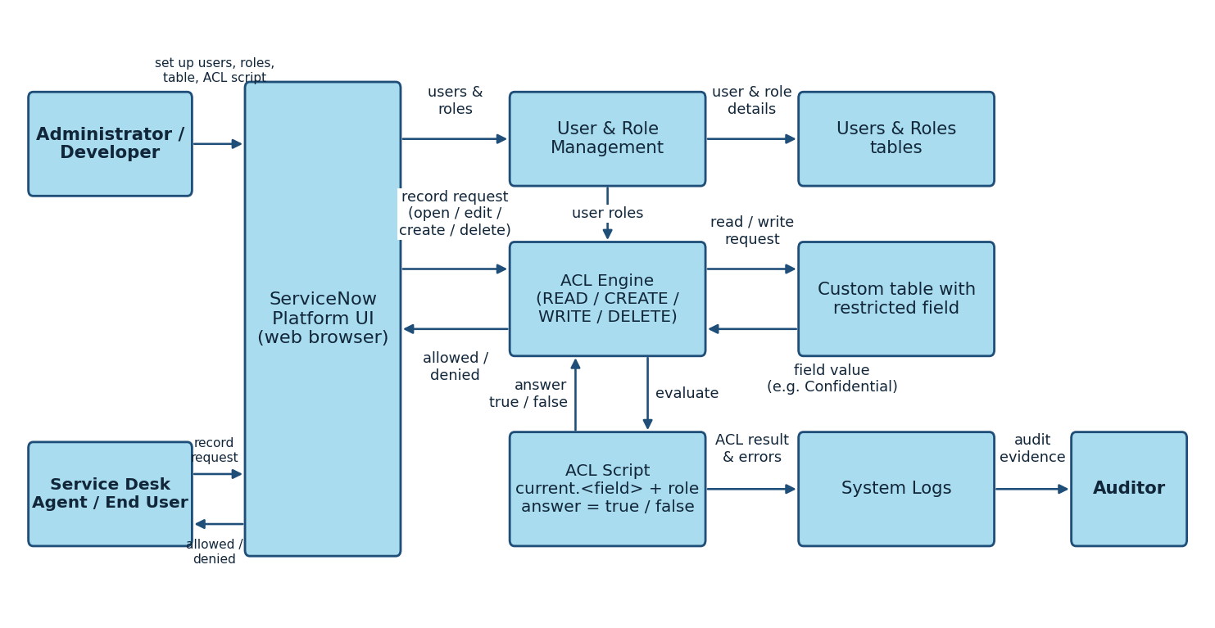
Figure 1: Architecture and data flow of the Script-Controlled ACL solution

5. PROJECT PLANNING & SCHEDULING

5.1 Project Planning
Product Backlog, Sprint Schedule, and Estimation
Sprint | Functional Requirement (Epic) | User Story Number | User Story / Task | Story Points | Priority | Team Members
Sprint-1 | Users and Roles Creation | USN-1 | As an administrator, I can create users so that accounts exist for testing and using the access rules. | 2 | High | Divya A
Sprint-1 |  | USN-2 | As an administrator, I can create roles and assign them to users. | 1 | High | Divya A
Sprint-1 | Table Creation | USN-3 | As an administrator, I can create a table with a field that holds the restricted value. | 1 | High | Dharshan Rajaram
Sprint-1 | ACL – READ | USN-4 | As a developer, I can write a script-controlled READ ACL that checks current.<field> and the user’s role. | 5 | High | Dharshan Rajaram
Sprint-2 | ACL – CREATE | USN-5 | As a developer, I can create a CREATE ACL so that only authorized roles can create records. | 3 | High | Dinesh Rajan
Sprint-2 | ACL – WRITE | USN-6 | As a developer, I can create a WRITE ACL so that only authorized roles can edit restricted records. | 3 | High | Dharshini V
Sprint-2 | ACL – DELETE | USN-7 | As a developer, I can create a DELETE ACL so that only authorized roles can delete restricted records. | 2 | Medium | Dharshini V
Sprint-3 | Testing and Verification | USN-8 | As a developer, I can test each ACL by impersonating different users and reading the system logs. | 3 | Medium | Dinesh Rajan
Sprint-2 | Record Access | USN-9 | As a service desk agent, I can open the records I am authorized to see and work on. | 2 | High | Dharshan Rajaram
Sprint-2 |  | USN-10 | As an end user, I can open my own records without being wrongly denied. | 2 | High | Dharshini V
Sprint-3 | Audit Evidence | USN-11 | As an auditor, I can see how access to restricted records is controlled. | 2 | Medium | Dinesh Rajan
Project Tracker, Velocity & Burndown Chart
Sprint | Total Story Points | Duration | Sprint Start Date | Sprint End Date (Planned) | Story Points Completed | Sprint Release Date (Actual)
Sprint-1 | 9 | 6 Days | 17 Feb 2025 | 22 Feb 2025
Sprint-2 | 12 | 6 Days | 24 Feb 2025 | 01 Mar 2025
Sprint-3 | 5 | 6 Days | 03 Mar 2025 | 08 Mar 2025
Velocity = total story points / number of sprints = 26 / 3 ≈ 8.67 story points per sprint. With a 6-day sprint, the average velocity per day is 8.67 / 6 ≈ 1.44 story points.
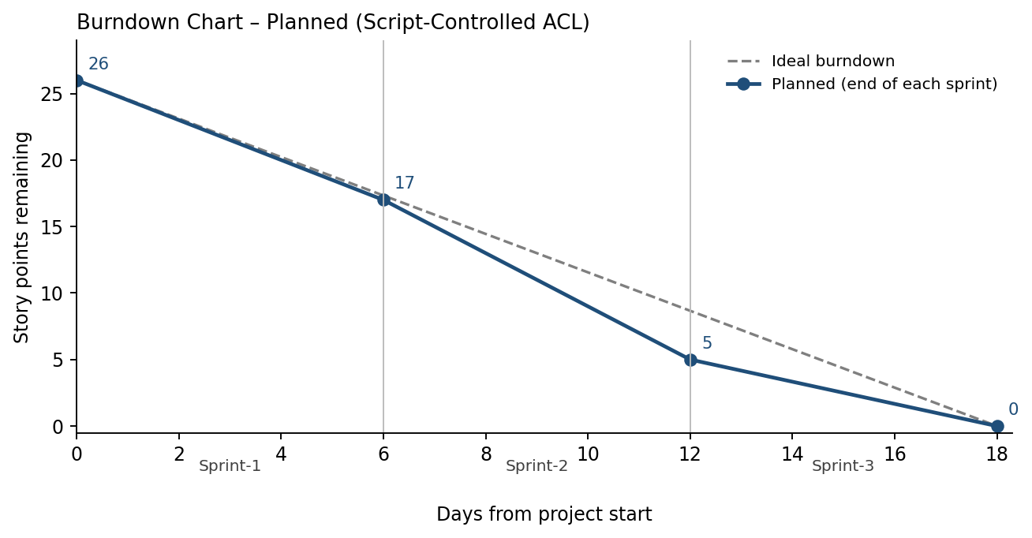
Figure: Planned burndown chart (the actual line will be added as sprints are completed)

6. FUNCTIONAL AND PERFORMANCE TESTING

6.1 Performance Testing
The functional and performance test scenarios are listed below. The Actual Result and Pass/Fail columns are to be filled in when the tests are run. The 15 UAT test cases (TC-001 to TC-015) and the defect and test case analysis are in the Project Development Phase document.
Test Case ID | Scenario (What to test) | Test Steps (How to test) | Expected Result | Actual Result | Pass/Fail
FT-01 | READ ACL – restricted field value (e.g., Confidential) | Impersonate an authorized and an unauthorized user; open the table list and the restricted record | Authorized user sees the record; unauthorized user does not
FT-02 | CREATE and WRITE ACL | Impersonate an authorized and an unauthorized user; create a record and edit a restricted record | Only authorized users can create and edit
FT-03 | DELETE ACL | Impersonate an authorized and an unauthorized user; try to delete a restricted record | Only authorized users can delete
FT-04 | ACL Script Check | Run allowed and denied actions; check the System Logs; try a record with an empty field value | Script returns true or false without errors
PT-01 | Response Time Test | Use a timer to check how long the table list and a restricted record take to open | Should be under 3 seconds
PT-02 | Concurrent Access Test | Open restricted records with several users at the same time | Access checks should not slow down
PT-03 | Large List Load Test | Open a table list with many records while the ACL script is active | Should work smoothly without crashing

7. RESULTS

7.1 Output Screenshots
Add the output screenshots in the spaces below.
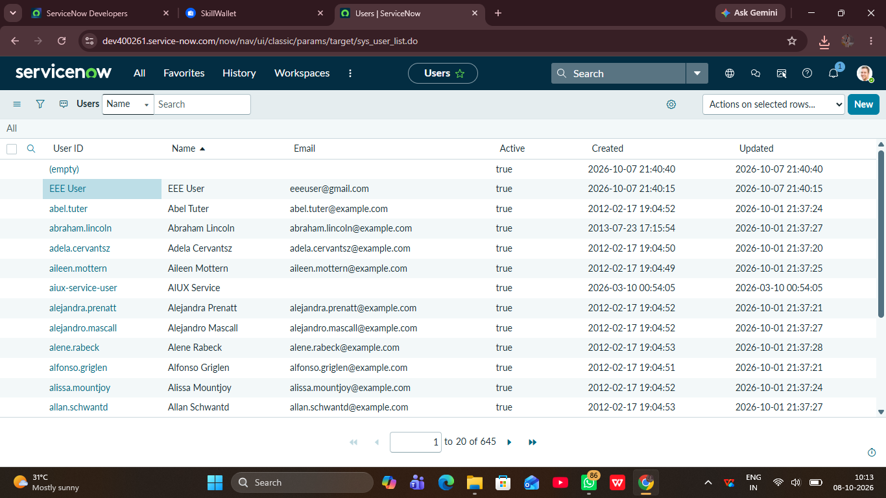
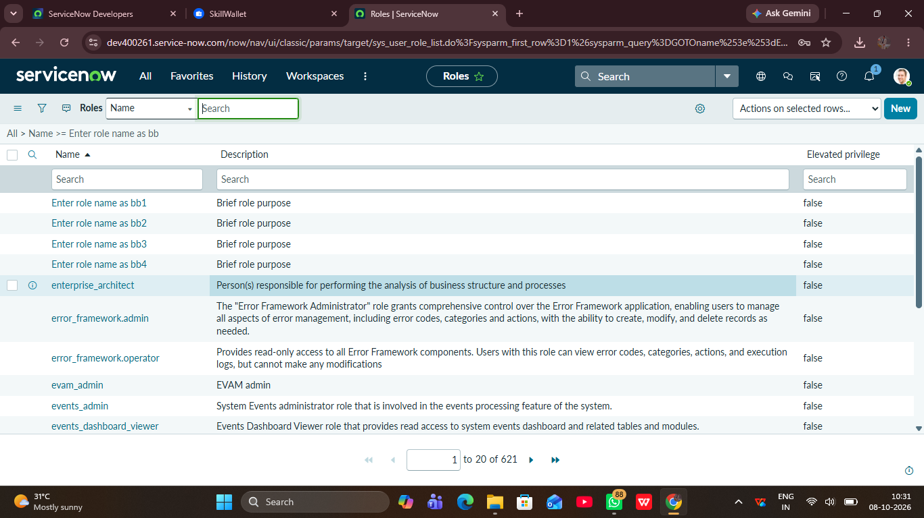
Figure 7.1: Users and roles created (Milestone 1)
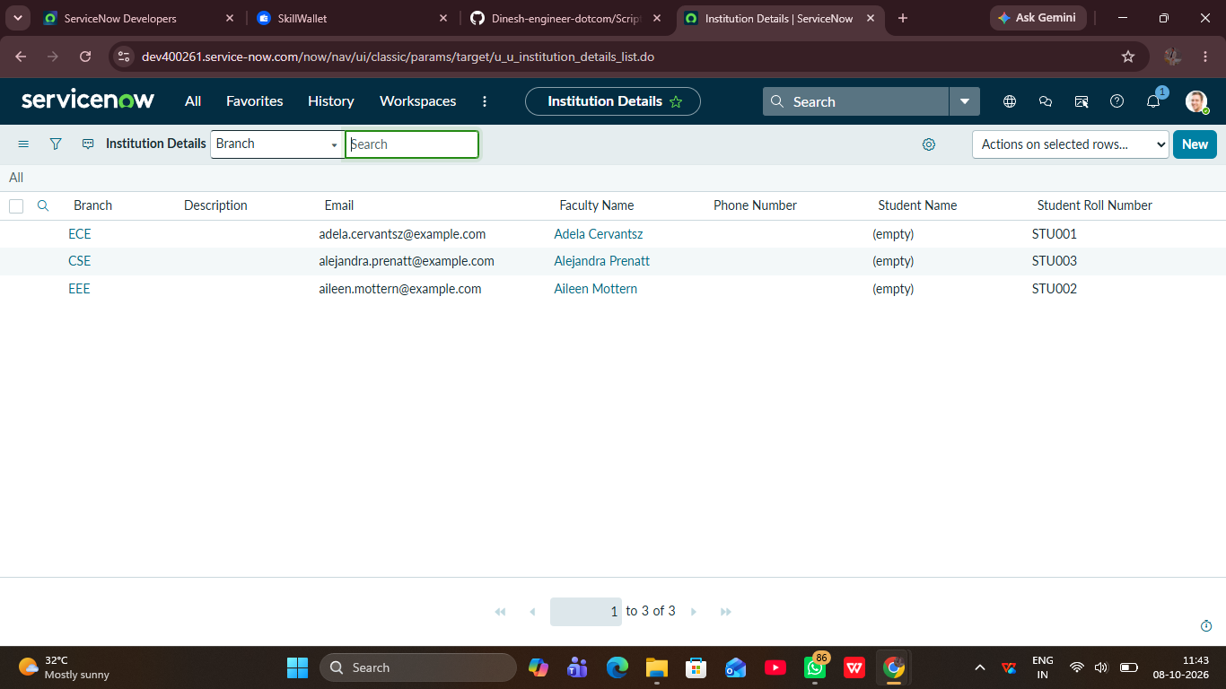
Figure 7.2: Custom table with the restricted field (Milestone 2)
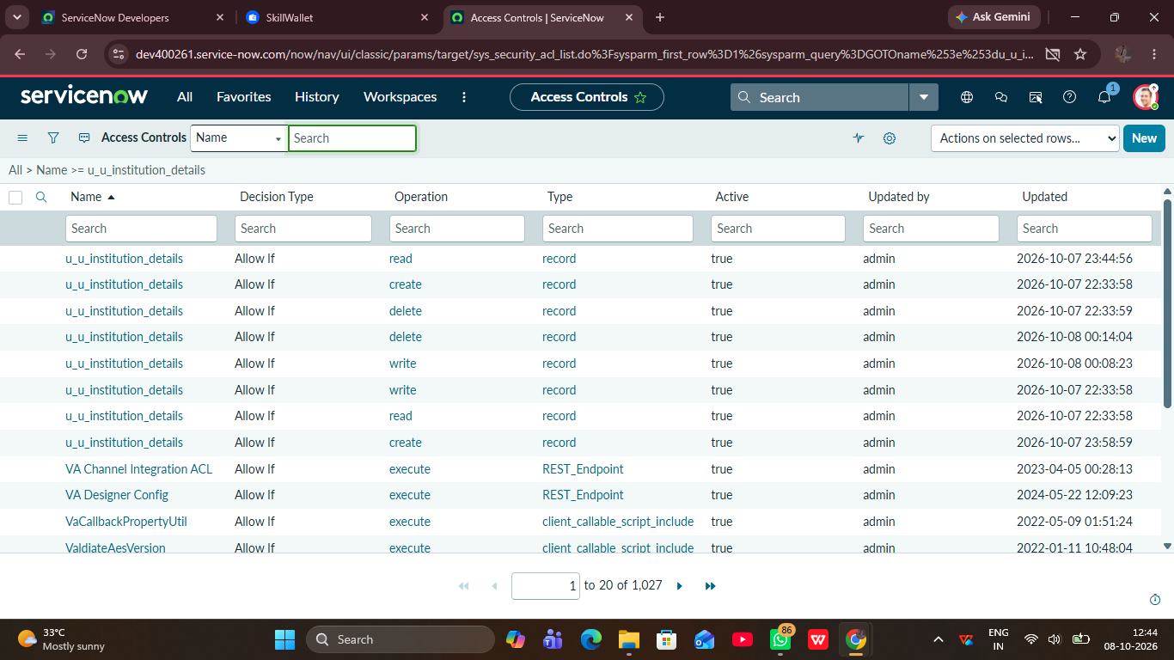
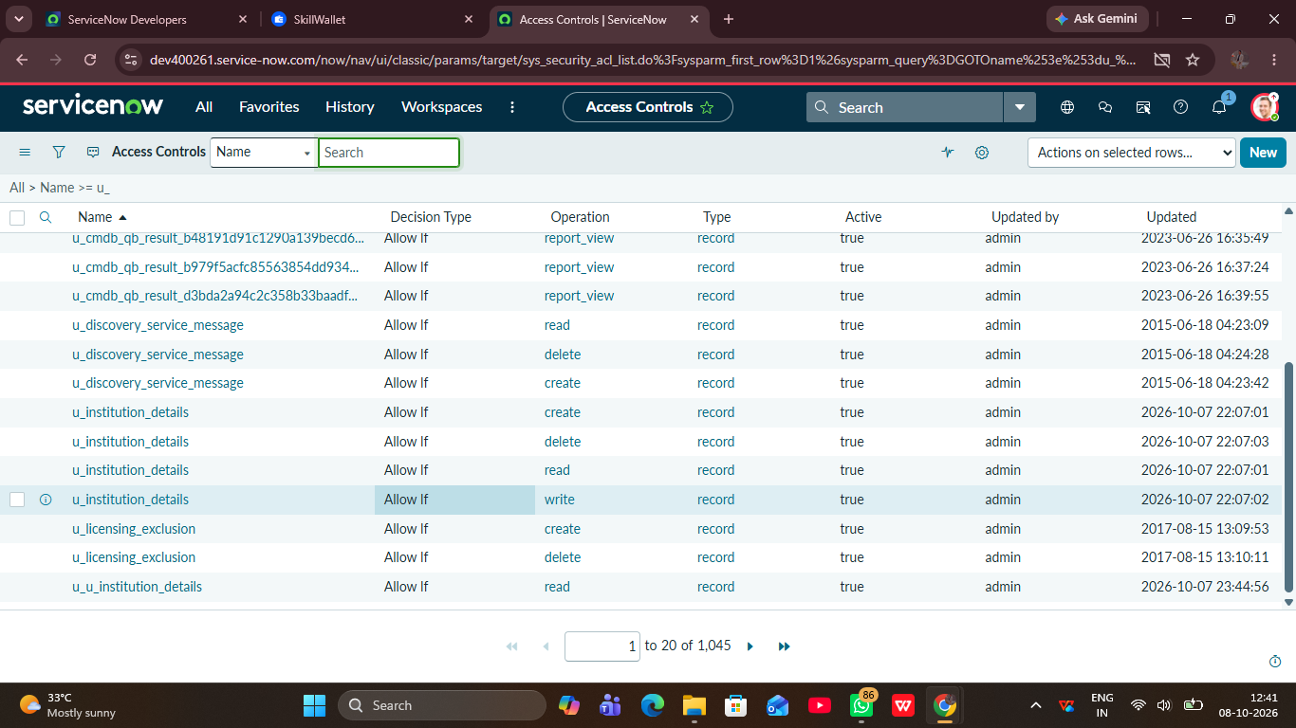
Figure 7.3: ACL script for READ, CREATE, WRITE and DELETE (Milestones 3–6)
Figure 7.4: Authorized user – restricted record visible
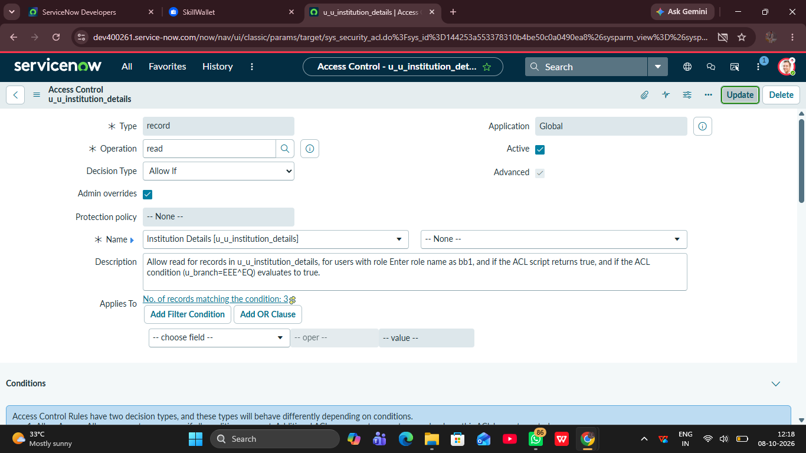
Figure 7.5: Unauthorized user – restricted record hidden or access denied
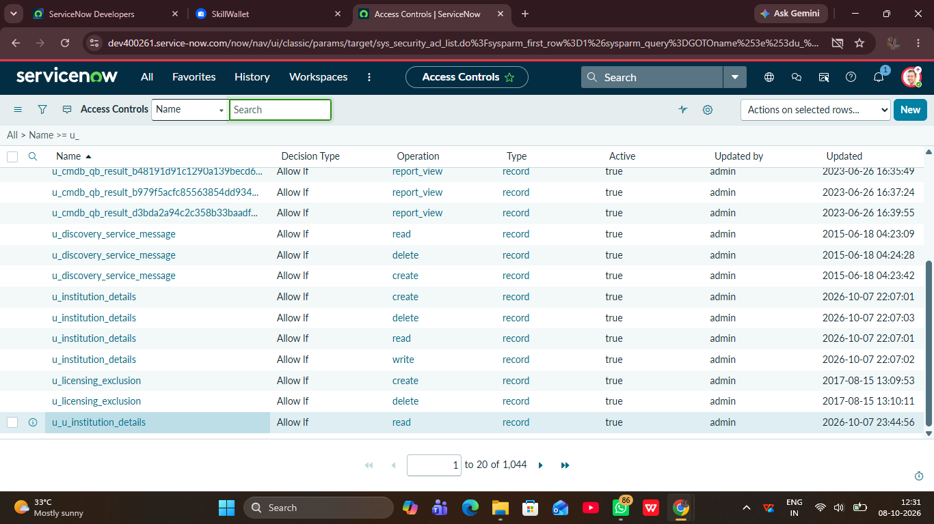
Figure 7.6: System log entry showing the ACL result

8. ADVANTAGES & DISADVANTAGES
Advantages
- Access is decided for each record by its field value, not only by the user’s role.
- Sensitive records stay hidden from users who should not see them, which supports audits and compliance.
- One script pattern can be reused for READ, CREATE, WRITE and DELETE and for other tables and fields.
- Authorized users and record owners can keep working on the records they need.
- The ACLs are enforced on the ServiceNow server, so they apply to lists, forms and reports.
Disadvantages
- ACL scripts are harder to write, test and debug than simple role-based ACLs.
- Results depend on the ACL evaluation order, so a mistake can block legitimate users or miss restricted ones.
- Scripts need to be reviewed when roles or fields change.
- A long or complex script can slow down lists and forms, so scripts must stay short.
- The solution only works inside ServiceNow.

9. CONCLUSION
The project shows how script-controlled ACLs in ServiceNow can restrict access to records by field value and user role. Users and roles, a custom table with a restricted field, and ACLs for READ, CREATE, WRITE and DELETE were planned across seven milestones and three sprints, and a set of functional, performance and UAT test cases was prepared to check that authorized users get access, unauthorized users are blocked, and record owners are not wrongly denied. Together these give precise, maintainable record-level security that reduces data-leak risk and audit concerns.

10. FUTURE SCOPE
- Apply the same script pattern to more tables and fields.
- Move the shared checks into a reusable Script Include so every ACL uses the same logic.
- Add exceptions for the record creator and the assignment group.
- Show a clear message to the user when access is denied.
- Build a dashboard to monitor denied access for the auditors.
- Keep a regular review of ACLs and test data sets for edge cases.

11. APPENDIX
Source Code (if any)
Add the ACL scripts used for READ, CREATE, WRITE and DELETE below. The pattern follows this outline (replace the field and role names with the ones used in the project):
answer = false;
if (current.<field_name> != '<restricted_value>' || gs.hasRole('<role_name>')) {
answer = true;
}

Source code: ACL scripts used in the project
Dataset Link
Not applicable – the project does not use a dataset.
GitHub & Project Demo Link
GitHub link: https://github.com/Dinesh-engineer-dotcom/Script-Controlled-ACL-Restrict-Record-Access-Based-on-Field-Value
Project demo link: __________________________________________
Part B
Project Documentation

1. Introduction
- Project Title: Script-Controlled ACL – Restrict Record Access Based on Field Value
- Team Members:
Team member | Role | Responsibility
Dinesh Rajan | Team Leader | Milestone 5 (ACL – WRITE) and Milestone 7 (project outcome)
Divya A | Team member | Milestone 1 (users and roles creation)
Dharshini V | Team member | Milestone 2 (table creation) and Milestone 6 (ACL – DELETE)
Dharshan Rajaram | Team member | Milestone 3 (ACL – READ) and Milestone 4 (ACL – CREATE)

2. Project Overview
- Purpose: To make sure that only authorized users can see or change records that carry a restricted field value, using script-controlled ACLs in ServiceNow, without blocking legitimate users from the records they need.
- Features:
  - Users and roles created and assigned for testing
  - Custom table with a field that holds the restricted value (e.g., Confidential)
  - Script-controlled ACLs for READ, CREATE, WRITE and DELETE that check current.<field> and the user’s role
  - Testing with Impersonate User and review of the system logs
  - Record owners are not wrongly denied

3. Architecture
- Frontend: No separate frontend was built. Administrators, developers and end users work in the ServiceNow Platform UI (list and form views) in a web browser.
- Backend: The backend is the ServiceNow platform. The ACL engine evaluates each request and runs the server-side JavaScript ACL script, which sets answer = true or false. No Node.js or Express.js server is used.
- Database: Data is stored in ServiceNow tables. There is no MongoDB; the project uses the following tables:
Table / record type | Use in the project
Users and Roles tables | Hold the test users, the roles and the roles assigned to each user
Custom table (Milestone 2) | Holds the records and the field with the restricted value (e.g., Confidential)
ACL records (Access Control) | Hold the READ, CREATE, WRITE and DELETE rules and their scripts
System Logs | Hold ACL results and script errors for testing and audit

4. Setup Instructions
- Prerequisites:
  - A ServiceNow instance and a user with administrator access
  - A web browser
  - Test users and roles (created in step 2 below)
- Installation: No code needs to be cloned and no environment variables are needed; everything is configured inside the instance.
- Sign in to the ServiceNow instance as an administrator.
- Create the users and roles and assign the roles to the users (Milestone 1).
- Create the custom table and add the field that holds the restricted value (Milestone 2).
- Create the READ, CREATE, WRITE and DELETE ACLs on the table and add the ACL script to each (Milestones 3–6).
- Test the ACLs with Impersonate User and check the System Logs (Milestone 7).

5. Folder Structure
- Client: Not applicable. There is no React frontend; the user interface is provided by the ServiceNow Platform UI.
- Server: Not applicable. There is no Node.js backend. The configuration is organized inside the instance as follows:
Configuration item | Where it is in ServiceNow
Users | User Administration > Users
Roles | User Administration > Roles
Custom table and restricted field | System Definition > Tables
ACLs and ACL scripts | System Security > Access Control (ACL)

6. Running the Application
There are no npm commands. The application runs on the ServiceNow instance:
- Frontend: Not applicable (no npm start). Open the instance in a web browser and sign in.
- Backend: Not applicable (no npm start). The ACLs run on the instance as soon as they are saved and active.
- To check the behaviour: Open the custom table list, then use Impersonate User to switch between the authorized and unauthorized test users.

7. API Documentation
No custom API endpoints were created for this project, so there are no request methods, parameters or example responses to document. Access control is enforced by the ACL engine for every request that reaches the table, whether it comes from a list, a form or a report.

8. Authentication
Authentication and authorization are handled by the ServiceNow platform:
- Authentication: Users sign in to the instance, and the platform manages the session. The project does not create its own tokens or sessions.
- Authorization: Roles are assigned to users, and the ACL script for each operation checks the user’s role and the record’s field value, then sets answer = true (allow) or false (deny).
- Testing access: Impersonate User is used to check the result for each role.
Operation | Allowed when | Denied when
READ | The record does not carry the restricted value, or the user has the required role | The record carries the restricted value and the user lacks the required role
CREATE | The user has an authorized role | The user does not have an authorized role
WRITE | The user has an authorized role for the restricted record | The user does not have an authorized role
DELETE | The user has an authorized role for the restricted record | The user does not have an authorized role

9. User Interface
Add screenshots of the user interface in the spaces below.
Figure 9.1: Table list view as the authorized user
Figure 9.2: Table list view as the unauthorized user
Figure 9.3: Record form for a restricted record (open and denied)

10. Testing
The testing strategy checks positive and negative cases for every operation:
- 15 UAT test cases (TC-001 to TC-015) cover users and roles, the table, and the READ, CREATE, WRITE and DELETE ACLs for authorized and unauthorized users, plus record owner access and log checks.
- Functional tests (FT-01 to FT-04) and performance tests (PT-01 to PT-03) check the ACL results, script errors, response time (under 3 seconds), concurrent access and large lists.
- Tools: Impersonate User, System Logs and a timer.
- Bugs are recorded with severity, status and steps to reproduce (BG-001 onwards).

11. Screenshots or Demo
Figure 11.1: Screenshot or demo of the working application
Demo link: ______________________________________________

12. Known Issues
No bugs have been logged yet because the UAT test cases have not been executed. Points to watch:
- The ACL evaluation order can change the result, so every new ACL should be tested for all roles.
- Scripts need to be re-tested whenever roles or the restricted field change.

13. Future Enhancements
- Apply the same script pattern to more tables and fields.
- Move the shared checks into a reusable Script Include.
- Add exceptions for the record creator and the assignment group.
- Show a clear message when access is denied.
- Build a dashboard to monitor denied access for auditors.

